LISTE DES MAITRES
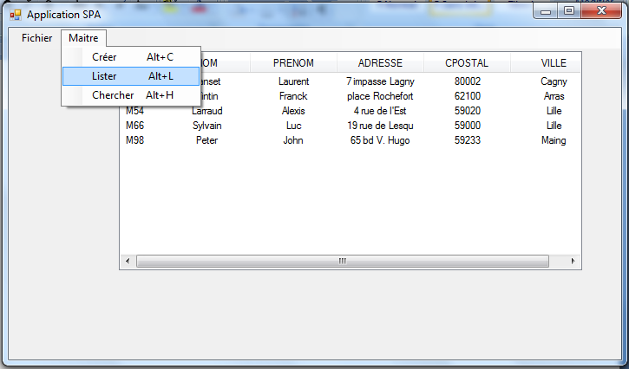
Fichiers Imports :
Imports System.IO
Imports System.Data
Imports System.Data.OleDb

Public Class frmSpa
.............................................. etc
Private Sub ListerToolStripMenuItem_Click(ByVal sender As System.Object, ByVal e As System.EventArgs) Handles ListerToolStripMenuItem.Click
Dim con As New OleDbConnection
' Définition de la chaîne de connection
con.ConnectionString = "provider=microsoft.jet.oledb.4.0 ; data source=C:\VBdev\spa.mdb"
con.Open() ' Ouverture connection à la BDD

Dim da As New OleDbDataAdapter("select * from maitre ", con)

ListView1.View = View.Details
' ListView1.GridLines=true pour afficher la grille du ListView
ListView1.Columns.Add("CODE ", 50, HorizontalAlignment.Center)
ListView1.Columns.Add("NOM", 100, HorizontalAlignment.Center)
ListView1.Columns.Add("PRENOM", 100, HorizontalAlignment.Center)
ListView1.Columns.Add("ADRESSE", 100, HorizontalAlignment.Center)
ListView1.Columns.Add("CPOSTAL", 100, HorizontalAlignment.Center)
ListView1.Columns.Add("VILLE", 100, HorizontalAlignment.Center)

Dim ds As New DataSet

'Remplissage a partir de la table résultat
da.Fill(ds, "maitre")

'Affichage des résultats dans la ListView1
Dim dr As DataRow
For Each dr In ds.Tables("maitre").Rows
Dim list = ListView1.Items.Add(dr(0))
list.SubItems.Add(dr(1))
list.SubItems.Add(dr(2))
list.SubItems.Add(dr(3))
list.SubItems.Add(dr(4))
list.SubItems.Add(dr(5))
Next

'fermeture de la connection
con.Close() ' Fermeture connection à la BDD
End Sub

Private Sub ChercherToolStripMenuItem_Click(ByVal sender As System.Object, ByVal e As System.EventArgs) Handles ChercherToolStripMenuItem.Click
frmMaitre.show()

End Sub

RECHERCHE D’UN MAITRE
Imports System.IO
Imports System.Data
Imports System.Data.OleDb

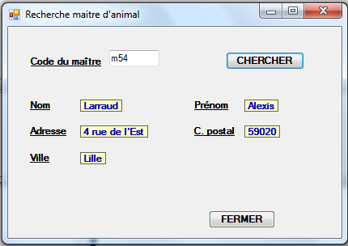

Private Sub Button2_Click(ByVal sender As System.Object, ByVal e As System.EventArgs) Handles Button2.Click
'Recherche d'un maitre d'après le code
Dim con As New OleDbConnection
' Chaîne de connection
con.ConnectionString = "provider=microsoft.jet.oledb.4.0 ; data source=C:\VBdev\spa.mdb"
con.Open() ' Ouverture connection à la BDD
Dim req As String = "select * from maitre where maitreCode = " & "'" & UCase(txtMaitre.Text) & "'" & ""
Dim da As New OleDbDataAdapter(req, con)
Dim ds As New DataSet

da.Fill(ds, "maitre")

lblNom.Text = ""
lblPrenom.Text = ""
lblAdresse.Text = ""
lblCpostal.Text = ""
lblVille.Text = ""
Dim dr As DataRow
For Each dr In ds.Tables("maitre").Rows
lblNom.Text = dr(1)
lblPrenom.Text = dr(2)
lblAdresse.Text = dr(3)
lblCpostal.Text = dr(4)
lblVille.Text = dr(5)
Next

If Len(Trim(lblNom.Text)) = 0 Then
MsgBox("Cet maitre est inconnu dans la base ! ")
End If
'fermeture de la connection
con.Close() ' Fermeture connection à la BDD
End Sub

