Base dbComptes / MySQL

CREATE TABLE CLIENT(cliNum CHAR(3) NOT NULL PRIMARY KEY, cliNom
VARCHAR(15), cliPrenom VARCHAR(15), cliCpostal CHAR(5), cliVille VARCHAR(15));

CREATE TABLE COMPTE(cpteNum CHAR(4) NOT NULL PRIMARY KEY, cpteType CHAR(1)
CHECK (cpteType ='C' OR cpteType='E'), cpteSolde NUMERIC(8,2), cpteClient CHAR(3) NOT NULL);

CREATE TABLE TYPECPTE(typeCpte CHAR(1) NOT NULL PRIMARY KEY, typeCpteLibelle VARCHAR(12));

CREATE TABLE OPERATION(opeNum INTEGER AUTO_INCREMENT NOT NULL PRIMARY KEY, opeType CHAR(1) CHECK (opeType='D' OR opeType='C'), opeCpte CHAR(4) NOT NULL, opeDate DATE, opeMontant NUMERIC(6,2));

ALTER TABLE COMPTE ADD CONSTRAINT fk_compte FOREIGN KEY (cpteClient)
REFERENCES CLIENT(cliNum) ON DELETE CASCADE;

ALTER TABLE operation ADD CONSTRAINT fk_compte FOREIGN KEY (opeCpte)
REFERENCES COMPTE(cpteNum) ON DELETE CASCADE;

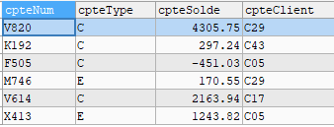
INSERT INTO operation VALUES('','C','M746','15/09/2020',237.55);
UPDATE compte SET cpteSolde=cpteSolde + 237.55 WHERE cpteNum='M746';
SELECT * FROM compte;
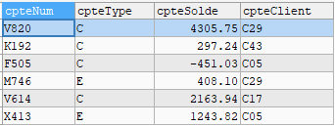
INSERT INTO operation VALUES(0,'D','F505','30/07/2020',12.76);
INSERT INTO operation VALUES(0,'D','F505','2020/06/09',40.84);
UPDATE operation SET opeDate='2020/11/28' WHERE opeDate='0000-00-00';
