Configuration d'un serveur de messagerie propriétaire :
MERAK MailServer 9.1.0

Henri TSOUNGUI, Lille, dec 2007

1-Installation du package version 9.1.0

antadiop:/usr/local# tar xzf merak-9.1.0.tar.gz
antadiop:/usr/local# cd merak*
antadiop:/usr/local/merak-9.1.0# ls
total 77564
-rw-rw-r-- 1 henri henri 3085 2007-09-18 09:26 INSTALL
-rwxrwxr-- 1 henri henri 6880 2007-09-18 09:26 install.sh
-rw-rw-r-- 1 henri henri 10175 2007-09-18 09:26 LICENSE
-rw-rw-r-- 1 henri henri 79319040 2007-09-18 09:26 merak-image-9.1.0.tar
antadiop:/usr/local/merak-9.1.0# ./install.sh

Software Licence Agreement for IceWarp Merak Mail Server

You agree not to decompile, disassemble or reverse engineer the IceWarp Merak Mail Server.

Sign-up procedure:

If you agree with the provisions of this Software License Agreement, please tick the
"I agree with the license agreement" chekbox below. If you do not agree with the
provisions of this Software License Agreement, please exit the system by clicking
"Cancel".

** You must accept this license agreement if you want to continue.
** Press ENTER to accept license or CTRL+C to quit

** Installation/Upgrade mode entered
**
** Installation prefix [/opt/merak]:
** Run services under user [root]: henri
** Run services under group [root]: henri
**
** Please check the following before continuing:
**
** Installation prefix: /opt/merak (will be created, installing)
** Services will run under user: henri (user exists)
** Services will run under group: henri (group exists)
** User henri is a member of group henri
**
** Press ENTER to continue, CTRL+C to quit

** Creating /opt/merak directory
** Extracting distribution
** Please wait...
** Changing permissions
**
** Press ENTER to continue, CTRL+C to quit

** Do you want Merak Mail Server to start automaticaly on reboot? [Y/n] y
**
** Default runlevel seems to be 2
** Please note that existing initscript will be replaced by the new version
**
** Add Merak Mail Server to runlevel 2? [Y/n] y
** Initscript install problem, check permissions
** Do you want to run Merak Mail Server Wizard now? [Y/n] y

**
** Merak Mail Server
** © 1999-2006 IceWarp Ltd.
** Wizard configuration assistant
**
** Logging is enabled to the following files for future reference:
** Errors: /opt/merak/logs/wizard/merak-wizard-error.log
** Actions: /opt/merak/logs/wizard/merak-wizard.log
**
** Root menu
** You have the following options:
**
** [1] Daemon Management
** [2] Accounts and Domains Management
** [3] Database setup
** [4] Advanced options
**
** [0] Return
** [Q] Exit
**
** Enter your choice: 1
**
** Daemon Management
** You have the following options:
**
** [1] Start Merak Mail Server
** [2] Stop Merak Mail Server
** [3] Add services to current runlevel
** [4] Remove Services from current runlevel
**
** [0] Return
** [Q] Exit
**
** Enter your choice: 3
**
**
** Default runlevel seems to be 2
** Please note that existing initscript will be replaced by the new version
**
** Add Merak Mail Server to runlevel 2? [Y/n] y
** Initscript install problem, check permissions
**
** Daemon Management
** You have the following options:
**
** [1] Start Merak Mail Server
** [2] Stop Merak Mail Server
** [3] Add services to current runlevel
** [4] Remove Services from current runlevel
**
** [0] Return
** [Q] Exit
**
** Enter your choice: 1
**
Starting Merak Mail Server Service Helper Daemon: [ OK ]
Starting Merak Mail Server Service Control Daemon: [ OK ]
Starting Merak Mail Server SMTP Service Daemon: [ OK ]
Starting Merak Mail Server POP3/IMAP4 Service Daemon: [ OK ]
Starting Merak Mail Server Messaging Service Daemon: [ OK ]
Starting Merak Mail Server GroupWare Service Daemon: [ OK ]
**
** Daemon Management
** You have the following options:
**
** [1] Start Merak Mail Server
** [2] Stop Merak Mail Server
** [3] Add services to current runlevel
** [4] Remove Services from current runlevel
**
** [0] Return
** [Q] Exit
**
** Enter your choice: q
** You can rerun wizard at later time by running /opt/merak/wizard script
** Merak Mail Server was successfully installed or upgraded.
**
** Installator log is available in /root/merak-install.log
** Installator error log is available in /root/merak-install-error.log

Etat de merak mailserver ?

antadiop:/usr/local/merak-9.1.0# ps aux|grep merak

root 6055 0.0 0.1 2856 636 ? Ss 12:32 0:00 /opt/merak/merakd --user=1000 --group=1000 --capabilities= --installdir=/opt/merak --noserviceshenri 6059 0.0 0.6 12528 3548 ? Ssl 12:32 0:00 /opt/merak/control --user=1000 --group=1000 --capabilities= --installdir=/opt/merak --noservices
henri 6067 0.0 0.7 12420 3764 ? Ssl 12:32 0:00 /opt/merak/smtp --user=1000 --group=1000 --capabilities= --installdir=/opt/merak --noservices
henri 6075 0.0 0.3 8676 1756 ? Ssl 12:32 0:00 /opt/merak/pop3 --user=1000 --group=1000 --capabilities= --installdir=/opt/merak --noservices
henri 6083 0.0 0.3 8940 1628 ? Ssl 12:32 0:00 /opt/merak/im --user=1000 --group=1000 --capabilities= --installdir=/opt/merak --noservices
henri 6092 0.4 2.0 17808 10496 ? Ssl 12:32 0:00 /opt/merak/cal --user=1000 --group=1000 --capabilities= --installdir=/opt/merak --noservices
root 6175 0.0 0.1 3104 772 pts/2 R+ 12:33 0:00 grep merak
antadiop:/usr/local/merak-9.1.0# ps aux|grep pop
henri 6075 0.0 0.3 8676 1756 ? Ssl 12:32 0:00 /opt/merak/pop3 --user=1000 --group=1000 --capabilities= --installdir=/opt/merak --noservices
root 6179 0.0 0.1 3100 756 pts/2 R+ 12:33 0:00 grep pop

2-Création d'un domaine et d'utilisateurs

Nous allons créer un domaine nommé « linux.tme » et deux utilisateurs henri et dupont. Les adresses e-mail de ces utilisateurs sont : henri@linux.tme et dupont@linux.tme.
Pour ce faire, on lance l'interface semi-graphique de configuration et gestion des services « wizard » qui se trouve dans le répertoire /opt/merak.

antadiop:/opt/merak# ./wizard

**
** Merak Mail Server
** © 1999-2006 IceWarp Ltd.
** Wizard configuration assistant
**
** Logging is enabled to the following files for future reference:
** Errors: /opt/merak/logs/wizard/merak-wizard-error.log
** Actions: /opt/merak/logs/wizard/merak-wizard.log
**
** Root menu
** You have the following options:
**
** [1] Daemon Management
** [2] Accounts and Domains Management
** [3] Database setup
** [4] Advanced options
**
** [0] Return
** [Q] Exit
**
** Enter your choice: 2

**
** Accounts and Domains Management
** You have the following options:
**
** [1] Add new domain
** [2] Delete domain
** [3] Add new user
** [4] Delete user
**
** [0] Return
** [Q] Exit
**
** Enter your choice: 1
**
**
** Create new domain:
**
** Domain name: linux.tme
** Domain description: ras
** Administrator email address: henri@localhost
**
** OK? [Y/n] Y
** Domain created
** Add another domain? [Y/n] n
**
** Accounts and Domains Management
** You have the following options:
**
** [1] Add new domain
** [2] Delete domain
** [3] Add new user
** [4] Delete user
**
** [0] Return
** [Q] Exit
**
** Enter your choice: 3
**
**
** Create new account:
**
** Email address: henri@linux.tme
** Password: **
** Once again to confirm: **
** Full name: Henri
** System administrator? [Y/n] Y
**
** OK? [Y/n] Y
** Account created
** Add another user? [Y/n] Y
**
** Create new account:
**
** Email address: dupont@linux.tme
** Password: **
** Once again to confirm: **
** Full name: Dupont
** System administrator? [Y/n] n
**
** OK? [Y/n] Y
** Account created
** Add another user? [Y/n] n
**
** Accounts and Domains Management
** You have the following options:
**
** [1] Add new domain
** [2] Delete domain
** [3] Add new user
** [4] Delete user
**
** [0] Return
** [Q] Exit
**
** Enter your choice: q
antadiop:/opt/merak# ./wizard

**
** Merak Mail Server
** © 1999-2006 IceWarp Ltd.
** Wizard configuration assistant
**
** Logging is enabled to the following files for future reference:
** Errors: /opt/merak/logs/wizard/merak-wizard-error.log
** Actions: /opt/merak/logs/wizard/merak-wizard.log
**
** Root menu
** You have the following options:
**
** [1] Daemon Management
** [2] Accounts and Domains Management
** [3] Database setup
** [4] Advanced options
**
** [0] Return
** [Q] Exit
**
** Enter your choice: ASSERT: "firstOption == listItems.size() || found" in /tmp/buildd/kdelibs-3.5.5a.dfsg.1/./khtml/rendering/render_form.cpp (1248)
antadiop:/usr/local/merak-9.1.0# konqueror &

3-Administration par interface web

L'interface est accessible sur le port 32000 du serveur. Il faut bien sûr que le serveur Apache2 soit en fonctionnement.

-Dans le navigateur konqueror, nous insérons http://localhost:32000/admin/
Nous accédons à la page de connexion du serveur :

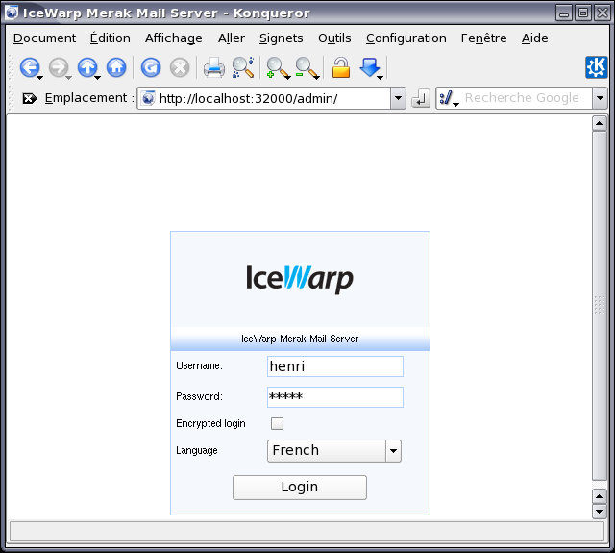

L'utilisateur étant reconnu, l'interface d'administration s'ouvre après le click sur Login.

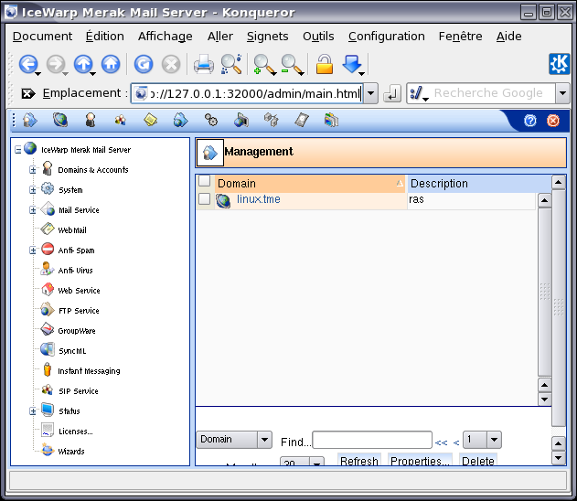
Cette interface nous permet d'administrer le serveur de manière très conviviale grâce aux menus et nombreuses options.
On peut déjà noter l'affichage du domaine créé avec le « wizard ». Un click sur le domaine linux.tme nous affiche les comptes utilisateurs présents : henri@linux.tme et dupont@linux.tme dont on peut modifier les caractéristiqus en les éditant.

Le menu System-Services nous montre les tous les services installés ainsi que leur état (vert-> actif, rouge -> arrêté).
Puisque tous les protocoles nécessaires pour l'envoi et la réception des courriels semblent fonctionner correctement, lançons un client de messagerie, en l'occurrence « evolution ».
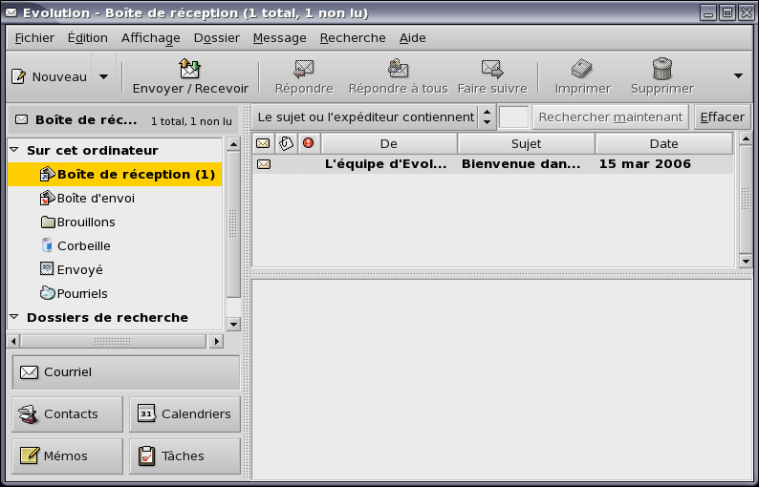
On a reçu le message de bienvenue du logiciel client. Testons maintenant l'échange de mail entre utilisateurs.
- Envoi d'un message de henri@linux.tme à dupont@linux.tme.

- Création de nouveaux utilisateurs et groupes : icones de la barre supérieure.

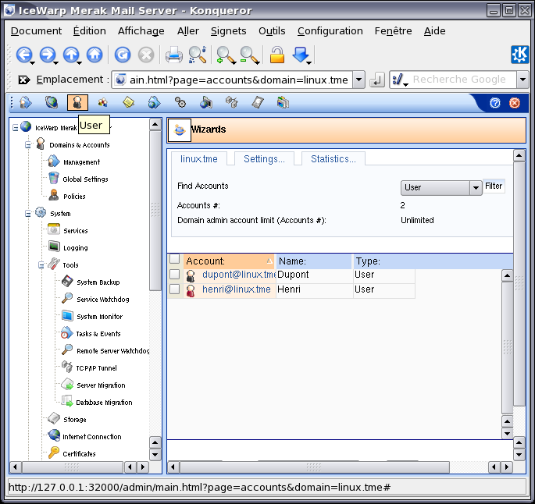

C'est à vous maintenant de dérouler et de tester cet applicatif en créant d'autres comptes utilisateurs, groupes et même en installant un autre serveur gérant un domaine autre et faire communiquer des domaines.
Mettez aussi l'accent sur la sécurisation des services et leur surveillance (monitoring) avec l'outil intégré.

BONNE DECOUVERTE !

H. TSOUNGUI

