Méthodes d’accès aux bases de données par VB.NET
H. TSOUNGUI
1)Accès aux données par VB2010
1-a)Base MS ACCESS 2003 ou 2007 par OLE
Imports System.Data.OleDb

Public Class frmOledbase

Public con As New OleDbConnection
- --------------------------------------------------------------------
Private Sub Button1_Click(ByVal sender As System.Object, ByVal e As System.EventArgs) Handles Button1.Click
Me.Close()
End Sub
- --------------------------------------------------------------------
Private Sub Autre_Click(ByVal sender As System.Object, ByVal e As System.EventArgs) Handles Autre.Click

Try
' Définition de la chaîne de connection
con.ConnectionString = "provider=microsoft.jet.oledb.4.0 ; data source=C:\VBdev\spa.mdb"
con.Close() ' Fermeture pour le cas où elle serait restée ouverte
con.Open() ' Ouverture connection à la BDD

voirEnreg() 'Exécuter une requête et voir les enregistrements résultats

con.Close() ' Fermeture connection à la BDD

Catch ex As Exception
MessageBox.Show(ex.ToString)
End Try

End Sub
- --------------------------------------------------------------------

Public Sub voirEnreg()
Dim dt As New DataTable ' Préparation de la table "résultats" de la requête
Dim ds As New DataSet
ds.Tables.Add(dt)

' Exemples de requêtes à tester - Les en-tête de colonnes sont à modifier
Dim da As New OleDbDataAdapter("select * from maitre where mVille <>'LILLE' ;", con)
'Dim requete As String = "select * from maitre where mVille ='LILLE' ;"
'Dim requete As String = InputBox("Tapez votre requête ")
'Dim da As New OleDbDataAdapter(requete, con)
'Dim da As New OleDbDataAdapter("select * from maitre;", con)

da.Fill(dt) ' Remplissage du Data_adaptateur (da)

Dim enreg As DataRow
lstviewOle.Items.Clear()

'Affichage des données dans un listview
For Each enreg In dt.Rows
lstviewOle.Items.Add(enreg.Item(0))
lstviewOle.Items(lstviewOle.Items.Count - 1).SubItems.Add(enreg.Item(1))
lstviewOle.Items(lstviewOle.Items.Count - 1).SubItems.Add(enreg.Item(2))
lstviewOle.Items(lstviewOle.Items.Count - 1).SubItems.Add(enreg.Item(3))
lstviewOle.Items(lstviewOle.Items.Count - 1).SubItems.Add(enreg.Item(4))
lstviewOle.Items(lstviewOle.Items.Count - 1).SubItems.Add(enreg.Item(5))
Next

End Sub
- --------------------------------------------------------------------
Private Sub Button2_Click(ByVal sender As System.Object, ByVal e As System.EventArgs) Handles btnRAZ.Click
lstviewOle.Items.Clear()
End Sub

End Class

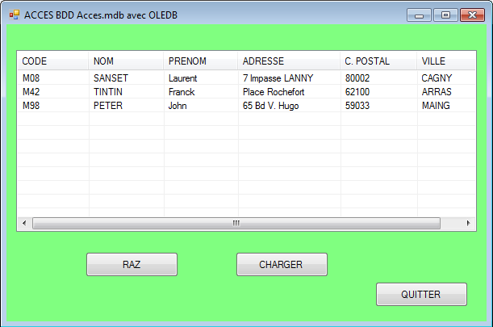

1-b)Connection VB.NET à une base MYSQL
Imports MySql.Data 'Importation des bibliothèques/Références OBLIGATOIRE
Imports MySql.Data.MySqlClient

Public Class frmMysqlproj
'NE PAS OUBLIER DE DEMARRER LA BASE MySQL (« EMPLOYES »)

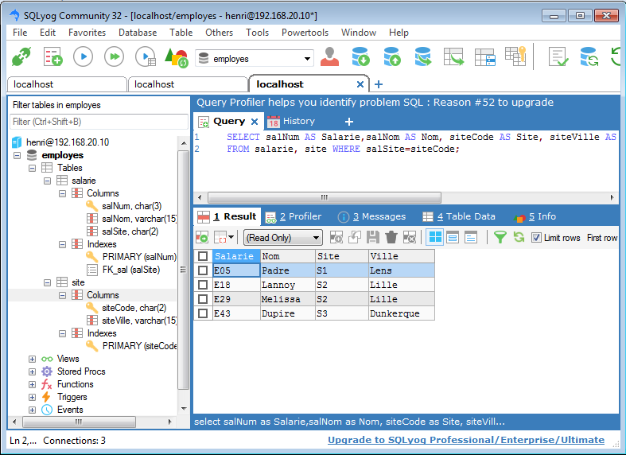
Fig. Accès par le client SQLYOG

Private Sub Button1_Click(ByVal sender As System.Object, ByVal e As System.EventArgs)
'Connection
' Dim connStr As String = "SERVER='localhost';DATABASE='employes';UID='henri';PASSWORD='henri'"
Dim connStr As String = "Database=employes;" & "Data Source=127.0.0.1;" & "User Id=henri;Password=henri;" & "Connection Timeout=20"
'Fin Connexion
Dim connection As New MySqlConnection(connStr)

Dim connexion As MySqlConnection = New MySqlConnection()
Dim adaptateur As MySqlDataAdapter = New MySqlDataAdapter()
Dim com As MySqlCommand = New MySqlCommand
Dim requete As String
'Dim tablereacteur As New DataTable

'Dim maliste As New List(Of String)
Dim myDataTable As New DataTable

Try
connexion.Open()
requete = "SELECT * FROM salarie;"

com.Connection = connexion
com.CommandText = requete
adaptateur.SelectCommand = New MySqlCommand(requete, connexion)

For i As Integer = 0 To myDataTable.Rows.Count - 1
'Affichage des valeurs des champs dans les textBoxes
txtNum.Text = myDataTable.Rows(i)("salNum").ToString
txtNom.Text = myDataTable.Rows(i)("salNom").ToString
txtSite.Text = myDataTable.Rows(i)("salSite").ToString
Next

connexion.Close()

Catch ex As Exception
MsgBox("erreur : " + ErrorToString())

End Try
End Sub

- ------------------------------------------------------------------------

Private Sub Button2_Click(ByVal sender As System.Object, ByVal e As System.EventArgs) Handles Button2.Click
'Chaîne de Connexion
Dim ConnexionSql As String = "Database=voyages;" & "Data Source=192.168.20.44;" & "User Id=root;Password=masplee;" & "Connection Timeout=20"
'Dim myDataTable As New DataTable

Try 'Intéressant pour gérer les erreurs
Dim requete As String = "SELECT * FROM employe" 'Requête SQL
Dim connection As New MySqlConnection(ConnexionSql)
Dim cmd As New MySqlCommand(requete, connection)

connection.Open() 'Ouverture connection

Dim reader As MySqlDataReader
reader = cmd.ExecuteReader() 'Execution du Reader, plus rapide

While (reader.Read())
'Les champs du dernier enreg. Les indices commencent à 0.
txtNum.Text = ((reader.GetString(0)))
txtNom.Text = ((reader.GetString(1)))
txtSite.Text = ((reader.GetString(2)))

'Affichage dans le comboBox
' ComboBox1.Items.Add((reader.GetString(0)))

End While

'Affichage champ "nom" dans le listBox
While (reader.Read()) 'Tant qu'il y a un enregistrement
ListBox2.Items.Add(reader.GetString("empNom"))
End While

reader.Close() 'Fermeture du Reader et de la connection à la base
connection.Close()
Catch ex As Exception 'Gestion d'erreurs
MessageBox.Show(ex.Message) 'Message de l'exception
End Try
End Sub
- -----------------------------------------------------------
Private Sub Button1_Click_1(ByVal sender As System.Object, ByVal e As System.EventArgs) Handles Button1.Click
Me.Close()
End Sub

- -----------------------------------------------------------

- --------------------------------------------------------------
Private Sub Button3_Click(ByVal sender As System.Object, ByVal e As System.EventArgs) Handles Button3.Click
Dim ConnexionSql As String = "Database=voyages;" & "Data Source=192.168.20.44;" & "User Id=root;Password=masplee;" & "Connection Timeout=20"
Dim myDataTable As New DataTable
Dim query As String = "SELECT * FROM employe" 'Requête SQL
Dim connection As New MySqlConnection(ConnexionSql)
Dim cmd As New MySqlCommand(query, connection)

connection.Open()

Dim reader As MySqlDataReader
reader = cmd.ExecuteReader()
'Dim i As Integer = 0
ListBox1.Items.Clear()
ListBox2.Items.Clear()
ComboBox1.Items.Clear()
While reader.Read()
'Les champs à recup. Les tables commencent à 0.
ListBox1.Items.Add(reader.GetString(0) & " - " _
& reader.GetString(1) & " - " & reader.GetString(2) & " - " _
& reader.GetString(3) & " - " & reader.GetString(4) & " - " _
& reader.GetString(5))
ComboBox1.Items.Add(reader.GetString(0) & " - " & reader.GetString(1))
ListBox2.Items.Add(reader.GetString(1) & " - " & (reader.GetString(4)))
End While

reader.Close()
connection.Close()

End Sub
- ------------------------------------------------------------------------------
Private Sub frmMysqlproj_Load(ByVal sender As Object, ByVal e As System.EventArgs) Handles Me.Load
'Jouer un peu de musique au chargement de la feuille

End Sub
- ---------------------------------------------------------------------------
Private Sub Button4_Click(ByVal sender As System.Object, ByVal e As System.EventArgs) Handles Button4.Click
ListBox1.Items.Clear()
End Sub
- ---------------------------------------------------------------------------
End Class

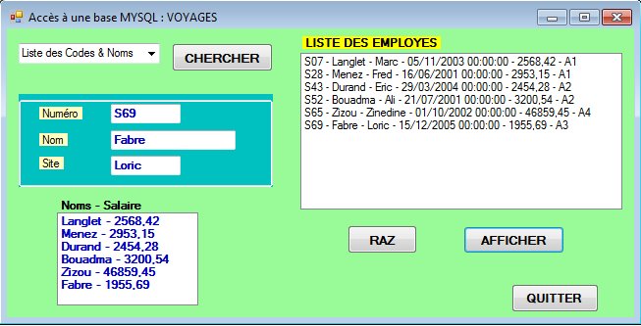
Base MYSQL “VOYAGES” sous Linux

