TD Contrôles courants
cases à cocher, boutons radio, boîte de liste, boîte de dialogue

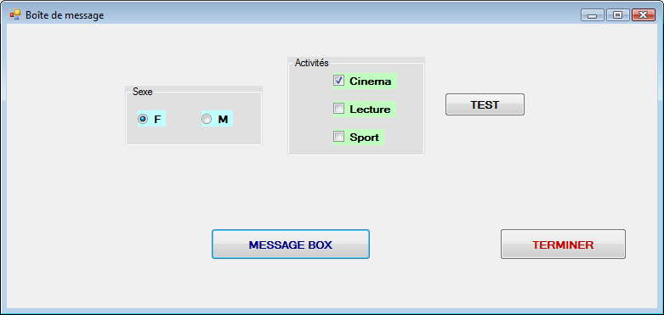

Code du bouton « TEST »

Private Sub Button3_Click(ByVal sender As System.Object, ByVal e As System.EventArgs) Handles Button3.Click
Dim sexe As String
Dim hobbies As String

sexe = ""
hobbies = ""
Me.Refresh()
If radbtn1.Checked Then
sexe = "F"
Else
sexe = "M"
End If
Me.Refresh()
MsgBox("Votre sexe est : " & sexe)

If chk1.Checked Then
hobbies = hobbies + "-Cinema "
End If
If chk2.Checked Then
hobbies = hobbies + "-Lecture "
End If
If chk3.Checked Then
hobbies = hobbies + "-Sport "
End If
MsgBox("Vos hobbies : " & hobbies)

End Sub

Code du bouton « MESSAGE BOX »

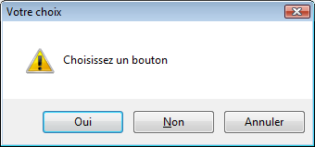
Private Sub Button1_Click(ByVal sender As System.Object, ByVal e As System.EventArgs) Handles Button1.Click
Dim rep, a, b, r

r = PlaySound("c:\sons\slot_payoff.wav", 1, 1)

a = "Choisissez un bouton" : b = "Votre choix"
'rep = MsgBox("Click sur un bouton", vbYesNoCancel, "Attente de reponse")
rep = MsgBox(a, MsgBoxStyle.Exclamation + MsgBoxStyle.YesNoCancel, b)
If rep = 6 Then
MsgBox(" Vous avez cliqué le bouton OUI")
ElseIf rep = 7 Then
MsgBox(" Vous avez cliqué le bouton NON")
Else
MsgBox(" OK pour ANNULER ")
End If
End Sub

Contenu du module(pour jouer un fichier son .wav)

Module ModMessage
Public Declare Sub MessageBeep Lib "user32" (ByVal wType As Long)

Public Declare Function PlaySound Lib "winmm.dll" Alias "PlaySoundA" (ByVal lpszName As String, ByVal hModule As Int32, ByVal dwFlags As Int32) As Int32

End Module

Autre exemple : gestion des étudiants

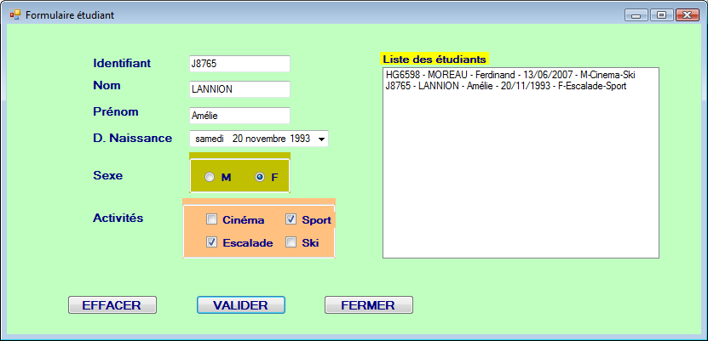

Code du bouton « VALIDER »(à améliorer)

Private Sub Button3_Click(ByVal sender As System.Object, ByVal e As System.EventArgs) Handles Button3.Click
Dim stud As etu
Dim hobbies As String

hobbies = ""

stud.id = Me.txtIdetud.Text
stud.nom = Me.txtNometud.Text
stud.pren = Me.txtPrenetud.Text
stud.nais = Me.dtpNaissance.Text

'recup sexe (boutons radio)
If Me.radF.Checked Then
stud.sexe = "F "
MsgBox("Vous êtes une fille")
Else 'Me.radF.Checked = false
stud.sexe = "M "
MsgBox("Vous êtes un garçon")
End If

'recup hobbies (cases à cocher)
If chkCinema.Checked Then
hobbies = hobbies & "-Cinema"
End If
If chkEscalade.Checked Then
hobbies = hobbies & "-Escalade"
End If
If chkSki.Checked Then
hobbies = hobbies & "-Ski"
End If
If chkSport.Checked Then
hobbies = hobbies & "-Sport"
End If

Me.lstetudiants.Items.Add(stud.id & " - " & stud.nom & " - " & stud.pren _
& " - " & stud.nais & " - " & stud.sexe & hobbies)
Me.Show()
Me.Refresh()

End Sub

Code du module(Modetu.vb à créer)

Module Modetu
Public Structure etu
Public id As String ' identifiant étudiant
Public nom As String ' nom
Public pren As String ' prénom
Public nais As Date ' date de naissance
Public sexe As Char ' sexe
End Structure

End Module

