Projet connection à une BDD MySQL avec VB.net
Installation du serveur MySQL-server sous linux ubuntu 16.04

henri@ubuntu16:~$ sudo -s
[sudo] Mot de passe de henri :
root@ubuntu16:~# apt install mysql-server
Lecture des listes de paquets... Fait
Construction de l'arbre des dépendances
Lecture des informations d'état... Fait

Les NOUVEAUX paquets suivants seront installés :
libevent-core-2.0-5 mysql-client-5.7 mysql-client-core-5.7 mysql-server
mysql-server-5.7 mysql-server-core-5.7
0 mis à jour, 6 nouvellement installés, 4 à enlever et 93 non mis à jour.
Il est nécessaire de prendre 18,2 Mo dans les archives.
Après cette opération, 23,5 Mo d'espace disque supplémentaires seront utilisés.
Souhaitez-vous continuer ? [O/n] o
...... … …… …… ……
root@ubuntu16:~# mysql -u root
ERROR 1045 (28000): Access denied for user 'root'@'localhost' (using password: NO)
root@ubuntu16:~# mysql -u root -p
Enter password:
Welcome to the MySQL monitor. Commands end with ; or \g.
Your MySQL connection id is 13
Server version: 5.5.5-10.0.31-MariaDB-0ubuntu0.16.04.2 Ubuntu 16.04

Copyright (c) 2000, 2017, Oracle and/or its affiliates. All rights reserved.

Oracle is a registered trademark of Oracle Corporation and/or its
affiliates. Other names may be trademarks of their respective owners.

Type 'help;' or '\h' for help. Type '\c' to clear the current input statement.

mysql> show databases;
+--------------------+
| Database |
+--------------------+
| information_schema |
| mysql |
| performance_schema|
| zabbix |
+------------------------------+
4 rows in set (0,26 sec)

mysql> create database employes;
Query OK, 1 row affected (0,04 sec)

mysql> use employes;
Database changed
mysql> grant all on *.* to henri@'%' identified by 'henri2007';
Query OK, 0 rows affected (0,14 sec)

mysql> exit;
Bye

root@ubuntu16:~# mysql -u henri -p
Enter password:
ERROR 1045 (28000): Access denied for user 'henri'@'localhost' (using password: YES)
root@ubuntu16:~# mysql -u root -p
Enter password:
Welcome to the MySQL monitor. Commands end with ; or \g.
Your MySQL connection id is 15
Server version: 5.5.5-10.0.31-MariaDB-0ubuntu0.16.04.2 Ubuntu 16.04

Copyright (c) 2000, 2017, Oracle and/or its affiliates. All rights reserved.

Oracle is a registered trademark of Oracle Corporation and/or its
affiliates. Other names may be trademarks of their respective owners.

Type 'help;' or '\h' for help. Type '\c' to clear the current input statement.

mysql> use employes;
Database changed
mysql> grant all on *.* to 'henri'@localhost identified by 'henri2017';
Query OK, 0 rows affected (0,00 sec)

mysql> grant all on *.* to 'henri'@'%' identified by 'henri2017';
Query OK, 0 rows affected (0,01 sec)

mysql> exit
Bye
Connexion distante autorisée ? voir le fichier my.cnf ou mysql.conf et commenter la ligne … 127.0.0.1
root@ubuntu16:/etc/mysql/conf.d# gedit mysql.cnf

root@ubuntu16:/etc/mysql#

[1]+ Fini gedit my.cnf
root@ubuntu16:/etc/mysql#

Création des tables SITE et SALARIE

root@ubuntu16:/etc/mysql# mysql -u henri -p
Enter password:
Welcome to the MySQL monitor. Commands end with ; or \g.
Your MySQL connection id is 16
Server version: 5.5.5-10.0.31-MariaDB-0ubuntu0.16.04.2 Ubuntu 16.04

Copyright (c) 2000, 2017, Oracle and/or its affiliates. All rights reserved.

Oracle is a registered trademark of Oracle Corporation and/or its
affiliates. Other names may be trademarks of their respective owners.

Type 'help;' or '\h' for help. Type '\c' to clear the current input statement.

mysql> use employes;
Database changed
mysql> create table site(siteCode char(2) not null primary key, siteVille varchar(15) not null);
Query OK, 0 rows affected (0,57 sec)

mysql> create table salarie(salNum char(3) not null primary key, salNom varchar(15) not null, salSite char(2) not null, salSalaire numeric(7,2));
Query OK, 0 rows affected (0,23 sec)

Création de la contrainte de clé étrangère
mysql> alter table salarie add constraint fk_salarie foreign key (salSite) references site(siteCode) on delete cascade;
Query OK, 0 rows affected (0,78 sec)
Records: 0 Duplicates: 0 Warnings: 0

mysql> desc site;
+-----------+-------------+------+-----+---------+-------+
| Field | Type | Null | Key | Default | Extra |
+-----------+-------------+------+-----+---------+-------+
| siteCode | char(2) | NO | PRI | NULL | |
| siteVille | varchar(15) | NO | | NULL | |
+-----------+-------------+------+-----+---------+-------+
2 rows in set (0,06 sec)

mysql> desc salarie;
+------------+--------------+------+-----+---------+-------+
| Field | Type | Null | Key | Default | Extra |
+------------+--------------+------+-----+---------+-------+
| salNum | char(3) | NO | PRI | NULL | |
| salNom | varchar(15) | NO | | NULL | |
| salSite | char(2) | NO | MUL | NULL | |
| salSalaire | decimal(7,2) | YES | | NULL | |
+------------+--------------+------+-----+---------+-------+
4 rows in set (0,03 sec)

Insertion des données dans les tables

mysql> insert into site values('s1','Valenciennes');
Query OK, 1 row affected (0,05 sec)

mysql> insert into site values('s3','Dunkerque');
Query OK, 1 row affected (0,04 sec)

mysql> insert into site values('s2','Lille');
Query OK, 1 row affected (0,01 sec)

mysql> insert into salarie values('E05','Padre','s1',2109.18);
Query OK, 1 row affected (0,05 sec)

mysql> insert into salarie values('E18','Lannoy','s2',1853.45);
Query OK, 1 row affected (0,03 sec)

mysql> insert into salarie values('E29','Melissa','s2',2215.87);
Query OK, 1 row affected (0,03 sec)

mysql> insert into salarie values('E43','Dupire','s3',2610.23);
Query OK, 1 row affected (0,07 sec)

Affichage des données des tables
mysql> select * from site;
+--------------+------------------+
| siteCode | siteVille |
+--------------+------------------+
| s1 | Valenciennes|
| s2 | Lille |
| s3 | Dunkerque |
+--------------+------------------+
3 rows in set (0,02 sec)

mysql> select * from salarie;
+--------+---------+---------+------------+
| salNum | salNom | salSite | salSalaire |
+--------+---------+---------+------------+
| E05 | Padre | s1 | 21
09.18 |
| E18 | Lannoy | s2 | 1853.45 |
| E29 | Melissa | s2 | 2215.87 |
| E43 | Dupire | s3 | 2610.23 |
+--------+---------+---------+------------+
4 rows in set (0,00 sec)

Travail à distance avec le client SQLYOG

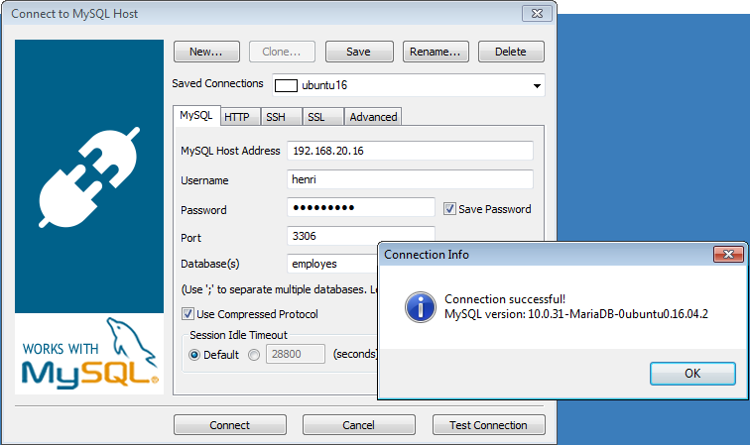
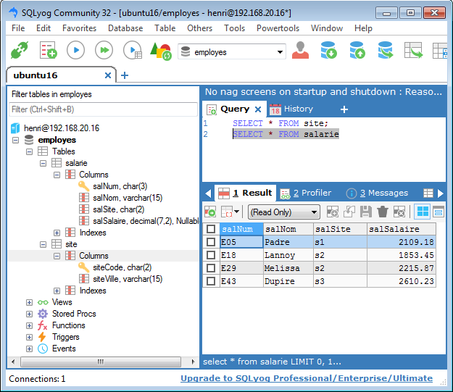

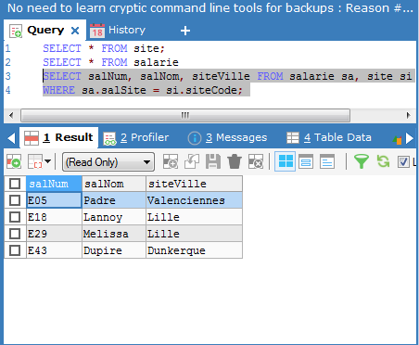

Projet d’accès à la base MySQL à partir d’une application sous VBnet
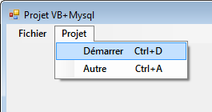
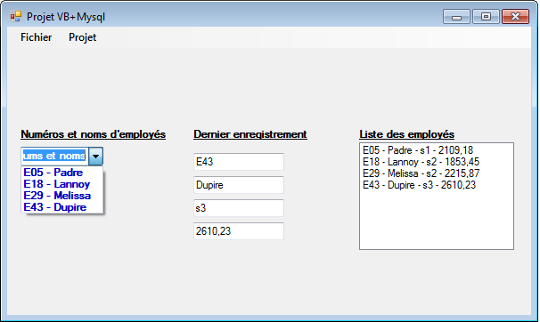
Objectif : se connecter à une BDD MySQL, exécuter des requêtes et afficher les résultats dans des objets conteneurs : combobox, textboxes, listboxes, listviews, datagridviews, etc.
Les bibliothèques importées avant la définition de la classe programme
Imports MySql.Data
Imports MySql.Data.MySqlClient
permettent d’utiliser des commandes préfixées mysql :
mysqlConnection, mysqlDatareader, mysqlCommand, etc.

Le code détaillé

Imports MySql.Data
Imports MySql.Data.MySqlClient

Public Class frmvbmysql
- ------------------------------------------------------------------------------------------------------------
Private Sub DémarrerToolStripMenuItem_Click(ByVal sender As System.Object, ByVal e As System.EventArgs) Handles DémarrerToolStripMenuItem.Click
'NE PAS OUBLIER DE DEMARRER LA BASE MySQL
'Chaîne de Connexion pour se connecter à la base
Dim ConnexionStr As String = "Database=employes;" & "Data Source=192.168.20.16;" & "User Id=henri;Password=henri2017;" & "Connection Timeout=20"
'Dim myDataTable As New DataTable

Try 'Intéressant pour gérer les erreurs
Dim cnx As New MySqlConnection(ConnexionStr)
Dim requete As String = "SELECT * FROM salarie;" 'Requête SQL
Dim cmd As New MySqlCommand(requete, cnx)

cnx.Open() 'Ouverture connection

Dim reader As MySqlDataReader
reader = cmd.ExecuteReader() 'Execution du Reader, plus rapide
Dim ligne As String
While (reader.Read()) 'Boucle d’affichage des résultants contenus dans le reader
'Les champs du dernier enreg. Les indices des champs (numéro, nom, site, salaire), commencent à 0.
txtNum.Text = ((reader.GetString(0)))
txtNom.Text = ((reader.GetString(1)))
txtSite.Text = ((reader.GetString(2)))
txtSalaire.Text = ((reader.GetString(3)))
'Affichage dans le comboBox
ComboBox1.Items.Add((reader.GetString(0)) & " - " & (reader.GetString(1)))
ligne = ((reader.GetString(0))) & " - " & ((reader.GetString(1))) & " - " & (reader.GetString(2)))
& " - " & ((reader.GetString(3)))
ListBox2.Items.Add(ligne) 'Affichage dans le listbox
End While

reader.Close() 'Fermeture du Reader et de la connection à la base
cnx.Close()
Catch ex As Exception 'Gestion d'erreurs
MessageBox.Show(ex.Message) 'Message de l'exception
End Try
End Sub
- --------------------------------------------------------------------------------------------------------
Private Sub AuteurToolStripMenuItem_Click(ByVal sender As System.Object, ByVal e As System.EventArgs) Handles AuteurToolStripMenuItem.Click
MsgBox("Auteur du programme : Henri T.", MsgBoxStyle.Information, "Développeur ")

End Sub
- -------------------------------------------------------------------------------------------------------
Private Sub FermerToolStripMenuItem_Click(ByVal sender As System.Object, ByVal e As System.EventArgs) Handles FermerToolStripMenuItem.Click
End
End Sub
End Class

