Cours du 18/01/2018 9h-12h DEUST IOSI 1 H. TSOUNGUI http://tsoungui.fr

Développement d’une interface client
Conception (designer)
frmClient
lstClient
btnRAZ
txtNom
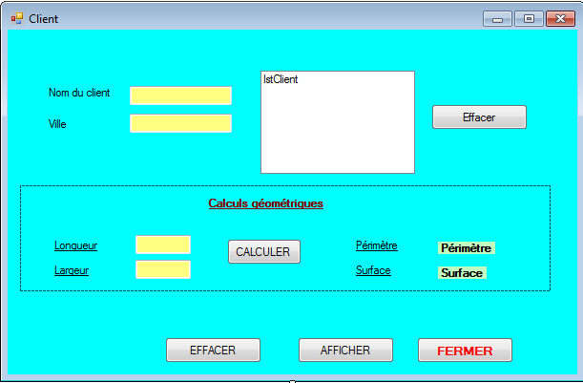
panel
txtLongueur
txtVille
lblPerim
txtLargeur
Le code attaché à l’objet frmClient
btnCalculer

btnAfficher
btnEffacer
Public Class frmClient

Private Sub btnFermer_Click(ByVal sender As System.Object, ByVal e As System.EventArgs) Handles btnFermer.Click
Me.Close()

End Sub

Private Sub btnEffacer_Click(ByVal sender As System.Object, ByVal e As System.EventArgs) Handles btnEffacer.Click
txtNom.Text = ""
txtVille.Text = " xxx "
Me.Refresh()
End Sub

Private Sub btnAfficher_Click(ByVal sender As System.Object, ByVal e As System.EventArgs) Handles btnAfficher.Click
Me.lstClient.Items.Add(txtNom.Text & " - " & txtVille.Text)
End Sub

Private Sub btnRaz_Click(ByVal sender As System.Object, ByVal e As System.EventArgs) Handles btnRaz.Click
lstClient.Items.Clear()
End Sub

Private Sub btnCalculer_Click(ByVal sender As System.Object, ByVal e As System.EventArgs) Handles btnCalculer.Click
'Calcul du périmètre
Dim longueur As Single : Dim largeur As Single
Dim P As Single : Dim S As Single

longueur = CSng(txtLongueur.Text)
largeur = CSng(txtLargeur.Text)
P = 2 * (longueur + largeur)

'Affichage du périmètre
lblPerim.Text = P.ToString & " mètres"
Me.Refresh()

'Calcul de la surface
S = longueur * largeur

'Affichage de la surface
lblSurface.Text = S.ToString & " mètres-carrés"

End Sub
End Class

Exemples d’exécutions

