Accès à une BDD MS SQL Server H. TSOUNGUI

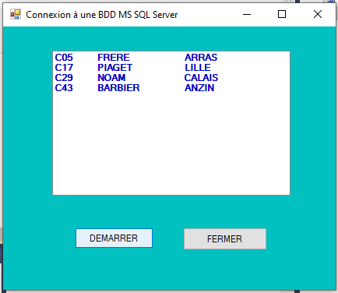

Imports System.Data.SqlClient (Pilote natif omniprésent sur les PC Microsoft)

Public Class frmDBCOMPTES

Private Sub Button1_Click(sender As System.Object, e As System.EventArgs) Handles Button1.Click
Me.Close()
End Sub

Private Sub Button2_Click(sender As System.Object, e As System.EventArgs) Handles Button2.Click
'Inherits System.Windows.Forms.Form

'Dim myConn As New SqlConnection
Dim myCmd As New SqlCommand
Dim myReader As SqlDataReader
'Dim myAdapter As New SqlDataAdapter

'Create a Connection object.
Dim myConn As New SqlConnection("Initial Catalog=DBCOMPTES;" & _
"Data Source=localhost;Integrated Security=SSPI;")

'Create a Command object.
myCmd = myConn.CreateCommand
myCmd.CommandText = "SELECT cliNum, cliNom, cliVille FROM client;"

'Open the connection.
myConn.Open()
myReader = myCmd.ExecuteReader()

'Affichage des résultats dans une listBox
Dim ligne As String
While myReader.Read()
ligne = myReader.GetString(0) & vbTab & myReader.GetString(1) & vbTab & vbTab & myReader.GetString(2) & vbLf
Me.lstClients.Items.Add(ligne)

End While
Me.Refresh()

Me.Show()
myReader.Close()
myConn.Close()
End Sub
End Class

